http://www.cgarchitect.com/resources/tutorials/smoke3d/tutorial8.asp
Advanced Lighting Techniques Part 1
by Montree T. (easyyong@hotmail.com) - Smoke3dStudio
If you wish to only use standard lights, the following method is necessary to make the scene look more realistic and detailed. In this tutorial I will show several examples to guide you though the process of simulating advanced realistic lighting. The most important thing however is to first make your own observations of lighting in photographs. (Not from any GI computer generated images.)
Using standard lights we have:
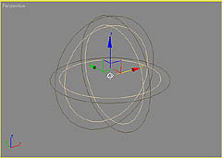
Omni lights with a spherical shaped beam that emits in all directions,
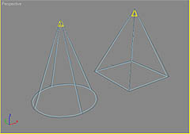
Spotlights with conical or pyramidal beams
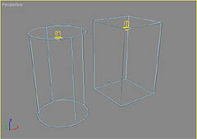
and direct light (cylinder or cube beams).
The mixture of these kinds of lights can produce an abundance of lighting and shadow effects.
Note: The following techniques may produce only lighting effect, you may need to create another group of lights to cast the shadows.
Two spot lights combined together to create a halogen light effect. Two cone layer effect.
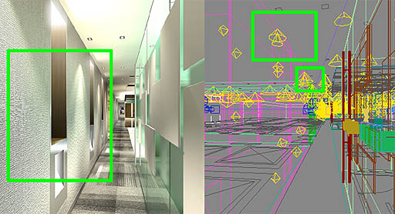
A group of omnis, as shown in the picture below. Some are created to be direct illumination from cope light and some are created for simulating indirect illumination around the area.
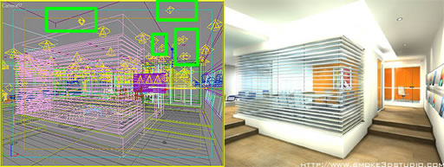
- Tube lights
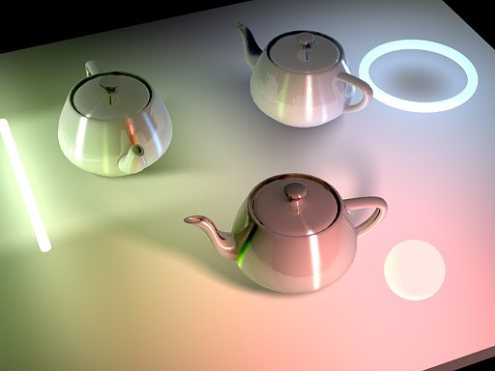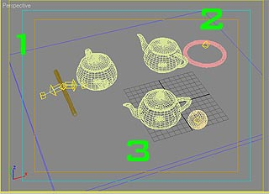
This is based upon my own observations on a tube lights. The beam of the light looks like the picture below.
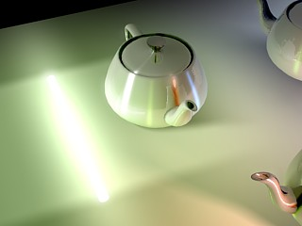
I place two free direct lights on the left and right of the cylinder to create the effect on the sides and put an omni in the middle. Use uniform scale to fit the omni's attenuation onto the cylinder. This creates the effect of the light from the top and bottom part of the cylinder. Change the shadow density to be negative so that better area shadow are created by the light.
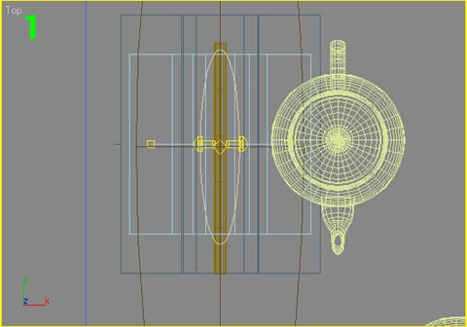
2. Ring Light
In my previous example, I just mentioned only the far attenuation, but in this case we need to use the near attenuation to create the ring effect. I use and omni and turn on the near attenuation. The area in between the near attenuation has no light so the effect looks like a ring.
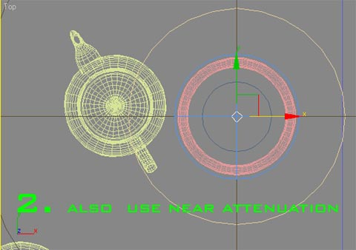
The blue circle in the picture above indicates the range of near attenuation.
3. Sphere Light
The sphere light is easy to create. We just put an omni inside a sphere object (that is light source). The light emits from every surface on the sphere as its attenuation form is as same as omni, but its shadow depends on how big the light source is, so we need to adjust the shadow's softness to follow the size of the light source.
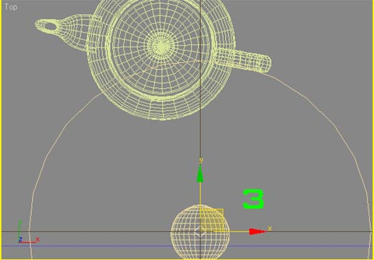
4. Environment Light
Environment light is light that is scattered around a scene. It's also considered as an area light as the light will effect in every part of the object.
A good example for this is skylight in an exterior scene:
"Skylight is the light from atmoshere, simulated by the reflectance of sunlight over the sky, cloud and everthing in the atmoshere. As the light is scattered and affected in every direction in atmosphere so we also considered it as a big dome of an area light in the scene in CG."

As mentioned in the previous example, first we imagine the area light shape as a 3d object (that we've assumed skylight shape is like a dome) and then place standard lights perpendicular to every surface on the object. In this case I choose freespots for faking the effect by placing them around the imagined dome. The dome light also result a good soft shadow effect.
1. Create a unit freespot light and change the color to light blue and enable overshoot.
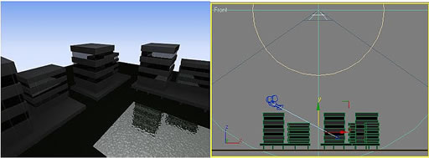
- Array and copy (instance) the light, following a half dome shape. In the example I use lesser numbers of spotlight to reduce the rendering time. (The more lights their are, the more realistic and detailed on shadows will be.)

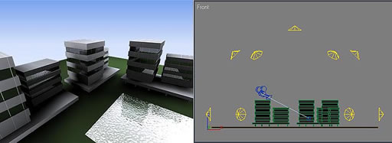
- Copy and mirror the spot light (no shadow casting) below the building. This is for green illumination from the green grass effecting on the buildings.
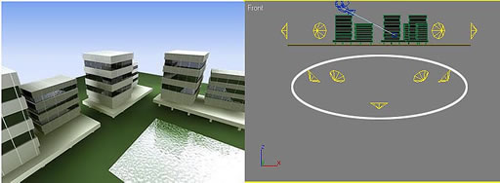
- Place a sunlight to complete the scene. 4. Place a sunlight to complete the scene.
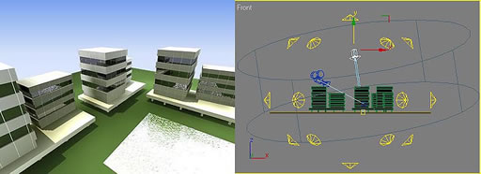
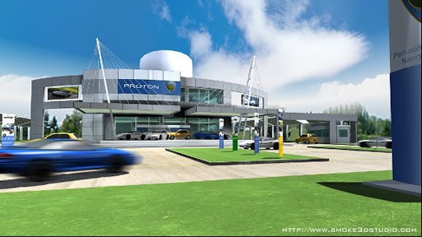
An exterior scene, lit with a skydome lighting technique.
Not only is skylight good for faking environment light, itis also suitable for any exterior and stand alone objects in the scene.

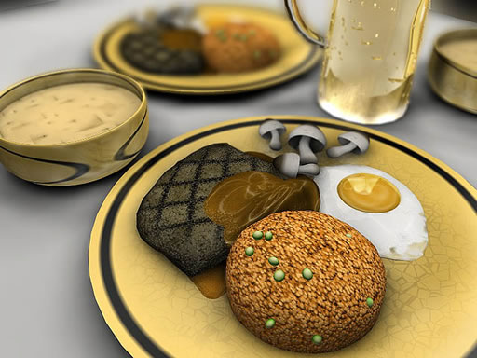
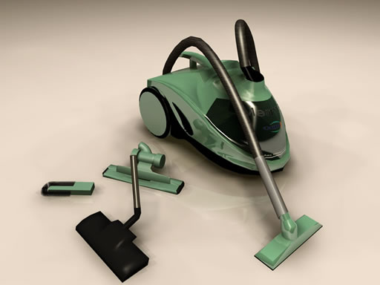

http://www.cgarchitect.com/resources/tutorials/smoke3d/tutorial9.asp
Advanced Lighting Techniques Part 2
by Montree T. (easyyong@hotmail.com) - Smoke3dStudio
5. Playing with light multipliers and shadow density
5.1. Negative multiplier parameter of light changes the light to be a shadow.
When we create a large scene some object's shadows may not appear correctly and some may be missed. A good way to create an accent shadow on an object is to place a light at the object's shadow position and change its multiplier to be negative.
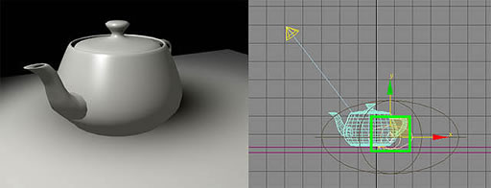
Placing a negative omni behind the teapot the effect look like a shadow.
When the multiplier is negative, the color will be effected as well. For example, a green colored light will appear inverse (become dark red) when the multiplier parameter is negative and white colored light will become black after we change its parameter to be negative.
5.2. Playing with shadow density
Now we are playing with positve shadow density. The postitive density (more than 1) causes the shadow color to be come brighter (with the exception of a black color shadow, the positive density will make the shadow appears darker).
Sometimes when we want to create a lighting effect behind an object which has a complex shape (ie. text or free from object), the first way is to use many omis, placing them to follow the object's contour.
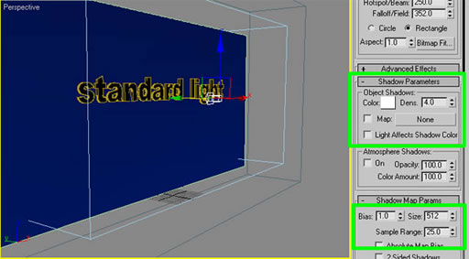
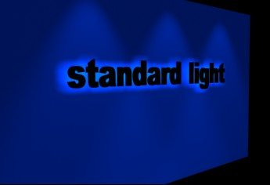
6. The second bounce and sub-ambient
The second important thing besides the ambient (that I've mention in Part 1 of this tutorial), that will make the scene look more interesting, is indirect illumination.
In the real world, there are many lights bouncing/scattering around. It's hard to imagine this and apply it to your own scenes started from scratch, unless you copy a photo or use a powerful GI plugin. We don't need to put all illumination in a scene. It's good enough if our eyes only capture a second or third bounce from the main light source ie. illumination from sunlight, illumination from a big light source and etc.
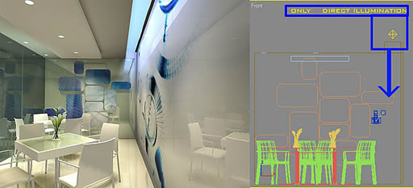
Placing omnis as a direct illumination from a diffuser.
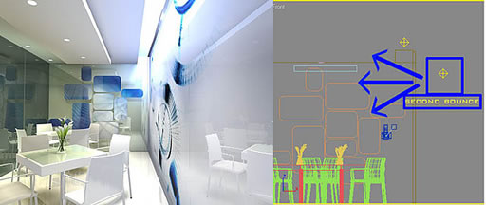
Adding omnis to simulate 2nd light bounce makes the scene look more interesting. Around the 2nd bounce area is also a sub-ambient light in the scene. This means the objects around the omni attenuation will be affected by its color. From the picture above, notice the white chairs and ceiling affected by the light- blue light from the 2nd bounce.
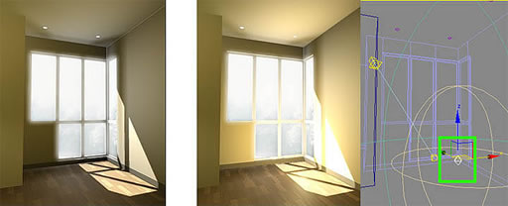
Middle and right: Placing omnis as an illumination from floor to the environment
http://www.brianlemay.com/Pages/tip.html
Tip of the Week #1
When you animate, do not simulate reality
Direct mimic of real life is often not desirable in animation. The medium demands a distillation of the information that will enhance, exaggerate or push the presentation into a strong visual statement.
"Actions should be stronger than real life. To do so is to take full advantage of the medium."
- Ham Luske.
Actions should be caricatured after the meaning is understood
"Go extreme with your actions. When you think youÍve gone far enough, go twice as far and youÍll be 1/2 way there."
- Art Babbitt
Animation is a series of drawings
The relationship is more important than the single frame. "Animation is not so much the art of drawings that move as the art of movement that is drawn."
- Norman McLaren
Phrasing
Most actions resolve into ANTICIPATION / ACTION / REACTION Keep this clearly in mind when working with dialogue. The tendency is to create major action for each voice accent. It is important to look at the phrase as a whole and subordinate some accents to allow the dominant accents to present themselves in the context of ANTICIPATION / ACTION / REACTION. In most cases it will be a collection of many words with varying accents to serve as ANTICIPATION for a dominant accent in relation to the overall phrase.
Anticipation
- Preparation
- Catches audiences eye
- Directional focus, points out object of the action. Usually moves in the opposite direction to add punch and contrast to the action itself.
- In acting it will indicate character / personality.
- Once anticipation is established, the action itself is usually self evident. (especially true in fast actions)
- Slower actions have more minimal anticipations.
Action
- PRIMARY ACTION is not caused by another force. It is the motivating force.
- Once an action is started it must be completed.
- Real action is a manifestation of force. All actions have meaning, some stir an emotional response, these become gestures.
- In dialogue, strong actions are cued by strong inflections in the spoken phrase.
Reaction
- SECONDARY ACTION occurs as a result of another action.
- Subject to the effects of gravity, elasticity, buoyancy.
- Clothing is always secondary, either fixed or flowing.
- Drapery is secondary to body action and gravity.
- Appendages ( ears, arms, tail, legs,) can be secondary to body actions and gravity or become primary when motivated by thoughts.
- Overlapping and secondary action action BEGINS within the action itself.
- Overlap a series of actions to enhance overall fluidity
- CHARACTERS are subject to ALL the mechanics of structure and gravity as well.
- There is opportunity to expose character in reaction.
Tip of the Week #2

The Animation Work Process - Part 1
Each individual animator probably has their own personal, individualistic way of approaching their scenes, you know those quirky things like locking themselves in their room, turning out all the lights and lying down under their animation desk with a sketch pad while listening to ABBA. Well, not all animators do this but there are two common ways of handling a scene. These are very general guide lines and are not to be taken as absolutes. There are many variables involved such as lipsync, the number of characters in the scene, the type of shot and the action taking place within the scene.
The first method is Analytical.
When you:
1) receive the scene and read through the storyboard,
2) talk the scene through with the director. Find out what the context of the scene is in relation to the scenes just before and the scenes after. What is the mental motivation of the character, the physical motivation?
3) If there is lipsync, listen to the track to find out what the intonation of the character is, what is the attitude.
4) Then take the scene and act it out. Act it out in front of a mirror, in front of a video camera, in front of a friend or by yourself. Try acting the scene in a number of different ways with different timings or different accent points.
5) Hyper analyze the whole scene.
6) Draw thumbnail sketches of the action.
7) Make any revisions necessary and then
8) rough animate.
The second method is Gut Instinct. (I actually made up this term). Now by this I don't mean that you're just winging it and hoping that some magic pixie dust will fall on your blank pages and the scene is animated. You still have to go through most of the basic steps outlined above in the Analytical method, pretty much up to step 3.
Step 4 is to lock yourself away and think the scene through in your head and then
5) rough animate based pretty much on your gut instincts.
The visual output is usually quite distinct. Animators who use the Analytical method usually have fairly clean key drawings due to the fact that they've worked the scene out in rough thumbnails already. Animators who use the "Gut Instinct" method usually work fairly rough and sketchy.
* It should be noted that this isn't an absolute statement and doesn't apply to every animator's work habits.
Try using the following points and adjust them to your own work system.

Daily Practice
Study through observation and research, draw, mentally visualize actions, draw, practice thumbnails until you arrive at a solid ability to shorthand your character, draw, draw, draw. As you gain experience through your drawing, you can allow your subconscious to search for various entertainment and expression possibilities. The more you practice the more you may learn about your character. This added knowledge may help in your approach to the storytelling and characterization.

Research
Be sure to focus on the basic principles of animation that are called for in the scene you are animating. Take notes in the lecture classes, follow along with the demonstrations yourself. Review your hand outs on the assignment and as questions if you're unclear about anything. Look for examples of the action you're doing in animated films, live action, and in real life. Act out the action yourself and analyze what your body is doing. Ask someone else to do the action and watch how they interpret it. Incorporate the basic principles involved into your research and your understanding of the action desired.

Visualize
We all have the ability to mentally visualize something. It isn't something that creates a solid image inside our head, rather it is more like something you can't quite grasp, it's almost there but not really, sort of like a ghost. When you close your eyes and think about something, let's say Bugs Bunny standing cocky, chewing on a carrot, you should be able to almost see it as a negative image. Since your eyes are closed all you see is black. Any image will have a white line to it. If you practice doing this visualization exercise, you will get better at it over time but it does take concentrated practice. The best time to do this is when you're all by yourself without any distractions and you can close your eyes and shut out the outside world for about 5 minutes. Can you think of any time during your day that you can do this? You might say that you don't have the time, you're just too busy, however, you , like most other humans do spend about 5 minutes a day in the bathroom sort of just sitting around... if you know what I mean. This is the perfect time to practice your mental visualization exercises. Mentally visualize the action and assess the entertainment value of your approach. How could this action be best staged?

Analyze
If the scene has dialogue, get a cassette of the soundtrack and listen to it for the emotional range required. Act the scene out to get a feel for what you want to do in the scene. Begin drawing your thumbnails.

Thumbnails
Thumbnail sketches are a way of shorthanding your drawing. It's far better to spend a few minutes doing these quick rough sketches to break down the action taking place rather than a lot of time drawing the character animation full sized only to find out that the animation posing doesn't work. It's time that could be better spent. Sketch to solve staging, action, and sequencing problems. Arrive at a plan for your keys.
After listening to the soundtrack, decide whether to play with it or against it. Usually, there are five major poses in the average scene - sometimes more, sometimes less. In analyzing the dialogue of a scene, listen for the emotions in the delivery of the lines. Be sensitive to the slightest nuance in the delivery as this can make a huge difference in the outcome of your character's acting. Also listen for the specific rhythm of the delivery. It is the animator's job to be purely analytical at this point. It is crucial to analyze the forces necessary to visually capture the energy of the delivery.
Focus on the silhouettes of each pose. Analyze the overall path of action through which the character moves in that scene and draw the path on the same page as the thumbnails. Study the exposure sheets and see where the major accents are. Block out only the major accents on the sheets.
Tip of the Week #3

The Animation Work Process - Part 2
Timing
In animating a scene, the animator must deal with two elements: TIME and FORCES. These must be fully analyzed before anything else is done. The combination of time and force dictate what the action will be and the analysis of the action will dictate what the poses will be.
Act out the scene again to get a natural feeling for the timing. Do it several times to arrive at a consistent performance with which you feel comfortable. Remember to consider the exaggeration and entertainment value that could be available within the scene. Do timing charts on the paths of action to help you break down the timing and spacing of the action. To the animator, time is represented by the spacing charts. Use a stopwatch to help you determine the number of frames and drawings you will need. Record your timing decisions on an exposure sheet.
Final Planning
Draw your overall path of action in relationship to the character and the fielding of the scene. Fill out the appropriate level on your exposure sheet. Some studios use odd numbers for animation on two's (1,3,5,7, etc.) and the even frames for any animation that is on one's (1,2,3,4,5,6, etc.). Draw your major keys and number them accordingly; 1, 17, 35, 53, etc. Decide if you've placed too much emphasis on one part of the scene and make any necessary revisions.
Write short descriptions, on your exposure sheets, of what bits of business are happening inbetween the poses and then time them out. As you are doing this, indicate what will be the anticipation, action, and reaction.
After initially timing out all your actions, check to see if you've given everything equal emphasis. Go back and find the major action that you are trying to emphasize. Add in the appropriate keys and check again. Perhaps you have put in too much action. If this is the case, throw out the unnecessary poses and give that time to the strongest action. Make the actions simple and direct. Actions should not distract from your major poses, they should enhance them.
Draw your timing charts connecting your major poses. Transfer the timing from your exposure sheets onto these charts.
Remember these key points:
Enlarge your thumbnail sketches to full size by either using a photocopier with an enlarge option or simply redraw them. These should roughly correspond to the layout posing as far as size, positioning within the field, and the relationship of the poses to the perspective within the layout background. You may need to revise your poses to strengthen their relationship to each other. Be flexible and don't feel like you're locked in to what you've drawn.
Double check your drawings, does it work with the layout? Don't accept your drawings too quickly, try them out on someone else.
Simplify. Once you've roughed the scene out go back and pick out the essence. You may have to remove a few drawings and/or modify some poses. In scenes with dialogue, don't move the character too much, be sure you can see the expressions.
Pose Test
Work out your rough poses very rough and dirty. Don't worry about the model or the little buttons on the shirt of the character. Use simple, basic shapes: spheres and cylinders to create the basic framework of the character pose. Think shorthand when doing these drawings, 20 to 30 seconds each. Go for the emotion or action within the scene. Shoot a pencil test and then show it to your instructor.
Rough Animate
Once your pose test works to your satisfaction... animate! Use your layout poses for size, construction and space but feel free to push or refine them as the action becomes more specific and concrete. Using the simple shapes, block out your key poses with your thumbnail sequence as a guide. Keep it loose-rough and flowing but solidly drawn.
Try to do the complete action from start to finish at a single sitting without interrupting your concentration. Be flexible. If you can see a better way forming that is an improvement over your thumbnails then make the changes.
When the key action is complete from start to finish, flip the stack of drawings to see how it looks and feels. Pay special attention to the arcs and paths of action on various body parts, arms, feet, head, etc. and plot all your arcs and points.
Shoot Pencil Test
With your exposure sheets in hand, shoot a pencil test. Record it on your video tape for reference and later when you review the test, write down any changes in timing you want to make while it's still fresh in your mind. Be sure to transfer the changes to your exposure sheets right away while the information is still fresh in your mind.
Show Somebody
Whether you personally assess your test as good or bad, get a second opinion from your instructor or someone whose opinion that you respect. If you don't get another opinion you may end up continuing to make the same mistakes over and over again. Immediately after the critique, sit down and write out the suggested changes or you may end up forgetting them. Don't be afraid to show someone your work. If you have this fear, ask yourself, "Why am I even doing this if I'm never going to show it to anyone?"
Revise
With a clear direction and understanding of what is necessary to make your scene read well, go back over your keys and make adjustments. Don't be afraid to throw out a large chunk of your drawings, or even the whole batch if it's really that bad. Sometimes, we fall in love with our drawings too much, that's the excuse you'll hear a lot. In reality, it's the loss of time in having to throw out a series of drawings that may have taken 5 - 10 minutes each. When you throw out 20 key drawings, that accounts for about 3 hours and 20 minutes of work in the garbage can. Too many times we hold onto bad drawings for this reason. At this point in your training it's: QUALITY OVER QUANTITY.
Complete The Scene
Add in any secondary extremes you feel are needed and then clean them up. Once these are done add your breakdowns and then shoot another pencil test to check the volumes, structure, and proportions of the character. Finally, add any inbetweens as are required.
A Disclaimer To Cover My Butt
So, now that I've taken you through this entire process, you can do with it what you want. Everybody will have their own approach and their own personal habits that they will bring to the drawing table, this is the way I learned to do it and it works for me. The important thing is to get the scene done in the most effective way possible to convey the emotion and action that suits both the character and the context. If you have some other way that someone has taught you and you feel comfortable with and it works for you and your employer/supervisor then, go for it.
A wonderful set of books to refer to on acting is the Stanislavski series entitled; An Actor Prepares, Building a Character, and Creating a Role. These can be ordered through any major bookstore or found at a bookstore that specializes in theatre related books.
Tip of the Week #4

SCENE PLANNING PROCESS
The following is one way of approaching scene planning. It's not everyone's way nor is it always necessary. Style of film, budget, and time restrictions dictate what and how much planning can be done, but remember,
IF YOU FAIL TO PLAN , YOU PLAN TO FAIL!
- General routine - Scenes in a production are planned from start to finish before the animation is begun. The story drawings are the expression of your thoughts. Timing, exposing, etc, all follow later.
Before Planning, Understand the Larger Context
In the entertainment / communication medium: What is communication? (idea sending- receiving idea)
What is entertainment? (Communication, film-maker's relation to audience). On a broad level all scene planning and visual analysis should be developed within the context of purpose, communication, story, direction, entertainment,character, motivation, acting. At each stage,fully understand the relationship of parts to whole:
Purpose to story
Story to audience
Story (What) to character (How and Why)
Sequence to story
Scene to sequence
Major poses to scene
Minor keys to major poses
Breakdown drawings to keys
Inbetweens to breakdowns
Know the story and how your particular scene fits into it
- Study the connecting scenes (preceding and following your scene)
- The character must not do anything that does not apply to the story:
- A simple walk across the floor should be done characteristically, as that particular character would do it, and it should be as direct as possible unless a funny gag is specifically called for.
- The audience should not be made to laugh in the wrong place, thus killing the buildup of a later gag.
Staging / Storyboard
Compose your action for the best clarity and staging possible. Consider the scene in the context of a series of shots and choose the composition, angles, and sense of space that you think will best stage your action. Do your visuals tell the story in pictures? Is it clear? Be sure what you want the audience to see is clear. Like a magician, lead the audiences eye to where you want them to look. Focus your actions. Focus your audience. Ask yourself, "How best can I show this to focus the audience?" Explore possibilities. Better to chose from 20 ideas than 1. Your visuals will be shown at 24 FPS. Be strong and clear.
Layout
Solve special problems through visual presentations, full size sketches, atmosphere sketches.This activates thinking about staging, acting, action phrasing. Rough out your perspective and character positions on a single drawing to test out the staging and composition of the total look of the scene before committing to the final background drawing.

Putting over the gag - using directness:
- Plan to keep the main action out in the clear, don't hide it with a poor silhouette
- Look at the drawings made by the Layout Artist to see whether they express strong poses - if they aren't clear, redraw to make it clear.
Mechanics
PERSPECTIVE -Work out action plan and placing of character within layout (sizes, relationships, eye direction).
SCALE -Show proper scale to other characters and objects.
ANGLES -What angle works best for staging clarity?
TECHNICAL -Trucks, pans, levelling, BG interaction.
Tip of the Week #5
CHARACTERIZATION
Characterization is the act of bringing to life and expressing the personality of a person, animal, or thing, through the exposition of thought processes, mannerisms, actions, dialogue, timing and physical appearance. We must know the character that we place in this context, who they are, how they are specific and unique in their actions and personality. Determine what will give the action character and identification with an audience. When actions are motivated by the character's thought process, then a personality will come through, not just a generic action. Discover the right kinds of action for the character and act them, feel them. Don't allow actions to appear routine.

Character
DESCRIPTION - Gender, age and history.
EMOTIONAL - Emotional makeup, prime emotional state.
PSYCHOLOGICAL - Motivations, thought processes.
PHYSICAL - In expressing a character's appearance, form and content are inseparable. Structure, shape, and details should reflect that.
ACTIONS - Mobility, mannerisms and timing. WHAT is on screen and HOW it is presented, the visual presentation of thinking time.
Anticipation
- Anticipate the action with "on-a-line" motion; the audience must be ready for what is going to happen.
- Kinds of Anticipation:
- Picking a flower - looking, coming up and going down into the pick.
- A jump - squat first.
- Running through a door - coming back on a line with the door.
- In general - always an 'up' before a 'down', a 'back' before a 'forward' a 'look' before a 'grab'; do the motion that leads into the motion.
- Anticipation done in an overlapping previous action when the scene is not very important.
Exaggeration - Caricature:
- Enlarge on drawings and tell the story just as clearly as possible with that drawing.
Examples: Man looking in a vase; he should be up above, leaning over it; there is no doubt he is looking into it.
Man hitting something with a hammer. Anticipation: arms back, body high and arched, on his toes; where he has hit the object he is down extremely low - object is squashed. There are likely no drawings from the place where the hammer starts to come down and squashed on the object - maybe a blur - then a rebound in the man from the force of the hit. That's the result - a moving hold of six to ten frames - then react into straight drawing.
- The assistant must not just 'clean up' - he is not working over the same ground, but is exaggerating what the animator has drawn.
- Enlarge the equipment (props) used by the character. e.g.: character with a big tennis racket, glove, bat - character is small in comparison.
- What to use in place of speed lines:
- Stretching is better than speed lines. e.g.: character with the racket arm pulling through - he is moving his arm a great distance in a short period of time, the stretch looks more solid than the speed lines.
Holds:
- The old way of looking at a 'hold' - as a number on an exposure sheet, something stiff and frozen.
- Try looking at 'holds' - as moving all the time; a 'moving hold' which is actually 3 trace back drawings of the held drawing and then cycled randomly, however, this can't be sustained on screen for a long time as it becomes obvious.
- Use a lot of drawings settling into a hold.
- coming out of a hold is generally slow; use more frames.
- 'Accent' the hold by coming into it with fewer drawings.
- It is the Result that is held. In exposing, you start the eye of the audience in one direction with one or two drawings; then you show the result; enough exposure must be put in to show the result; that is called a 'hold' - not one drawing, but a group of drawings!
Timing
- Work with the director in acting things out and timing them.
- Examples:
Walk: Soldiers march about 120 steps to the minute or two steps to the second, this works out to 12 frames per step (6 drawings on two's).
Run: On the above example - about twice as fast as the walk; 8 frames per step (4 drawings on two's but you may want to animate on one's to make the action read properly).
- Working with 24 frames per second;
- you know how long the character is going to be on the scene.
- you know how fast they move.
- you have acted it out in front of a mirror and timed yourself on it.
- you find out how long it takes the character to do it as the character would do it naturally, and how long it would take if you caricatured them, and figure how you can save space.
- you start working and put the punch in the strong points of action, conserving time on the unimportant points.
- Let the audience see what you want them to see.
- When the scene is finished, if you have placed too much stress on the unimportant things or not enough on the important things, you have not planned the scene properly.
Exposure Sheets
- A general rule: Fill in the numbers on the exposure sheets. Follow up with notes on drawings to show where to speed in and of the poses. (The number of exposures on each drawing and directions about speed).
- Most of the action will be on two's unless you have a very fast action or have lip sync where the dialogue is very rapid.
- Indicate action and any dialogue keys in little thumbnails in the action column to help you remember the phrasing for the scene.
- Phrase expressions to suit the dialogue; use body positions for the phrase, a head action to catch the words.
- On the lips, the main thing is to catch the closed mouth (b, p, and m's); the lip accent is the last thing to be worked on.
Tip of the Week #6

Topics Covered
• BASIC PRINCIPLES OF ACTION ANALYSIS
All animated action implies some type of reference (self or others).
First you must do something called, 'Isolation of the Action'
This implies some decision making . Explore many options and zero in on something unique and entertaining.

Clarify the Intent of the Action
By understanding the intent or reason for the action, the animator can then decide the specific way the action is to be performed.
PURPOSE - What is the purpose of this scene within the context?
ENTERTAINMENT - What is the entertainment value of this scene/ sequence/ phrase of action?
EMOTION - What is the core attitude of the character? What emotion is being communicated/ focused on? How is this emotion being revealed/played out?
ACTION - What should the character do in this scene to reveal intent/personality?
CHARACTERIZATION - This is one of the most important aspects of designing your action. When actions are motivated by the character’s thought process then a personality will come through, not just generic action.

Motion Principles
Understand the nature and physics of the action (i.e. primary forces, secondaries, stresses, compressions,etc.).
Understand the animation principles involved and where to apply them to enhance the expression of that action.
No motivating force is more important than the thought process. Primary action and locomotion is an extension and reflection of this force. Always locate what the primary motivating force is and how it works.
Visually, it will be difficult to watch more than one primary force at a time. But, if necessary, then the forces should relate.
Analysis
Analysis involves PERFORMING/ OBSERVING/ QUESTIONING/ RECORDING. Gather information from action research and record results.
PERFORMING (ACTING)
DOING the action provides a physical, experiential understanding of the action as to the SIZE of ,SPEED of , DIRECTION of, INTENSITY of the action. As self conscious as it might make you BE SURE to act out your phrase of action.
AT SPEED to analyze the effects of time and gravity.
SLOWED DOWN to analyze position and sequence of events and points of incidence within the action.
It is EXTREMELY important to continue to act out your scene AT SPEED. The tendency is to fracture the action into separate bits, that when analyzed, each at their own speed, make sense, but when these fractured bits are put together into a real time relationship there is invariably too much going on.
OBSERVING (VISUALIZING)
WATCH the action, from within, in a mirror, on videotape or film, of self or another. All of these provide a visual understanding of the action.
QUESTIONING
Ask, where do the extremes of action occur. Ask, what the sequence of the actions are, - what happens first? next? What are the relationships of timing and spacing of specific incidents in the overall phrase.
RECORDING
Utilize thumbnails to record action. The act of recording it forces seeing it in stages and completely, as a series of pictures and helps to plan staging and silhouette. Drawings should first have a function or purpose, then a graphic shape to express that function. Add path of action graph to thumbnails and explore timing.
© Copyright 1998
http://www.cgarchitect.com/resources/tutorials/smoke3d/tutorial1.asp
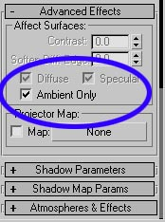
Lighting and Shadow Basics - Part 1
by Montree T. (easyyong@hotmail.com) - Smoke3dStudio
Ambient Light
Ambient light is one of the most important parts of creating a realistic rendering becuase it sets the time and mood of picture that you are trying to create.
The complete scene should be composed of a specular pass, a diffuse pass and an ambient pass. Some artists use only the default specular and diffuse settings, but I always like to use ambient light only as a main ambient light.
The examples, below are done without the ambient only light seeting checked.
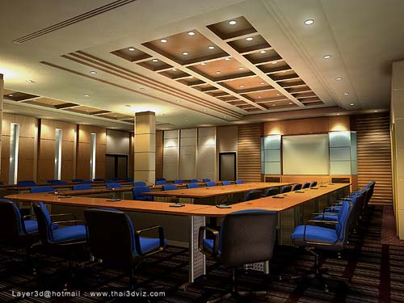
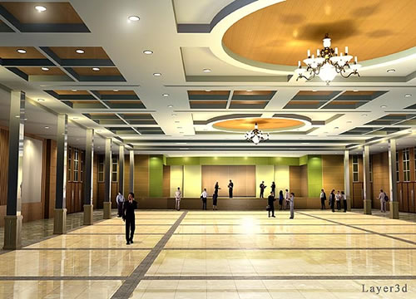
3D images by Layer3d@hotmail.com, www.thai3dviz.com

Compare with the scene, done with ambient only lights (below)
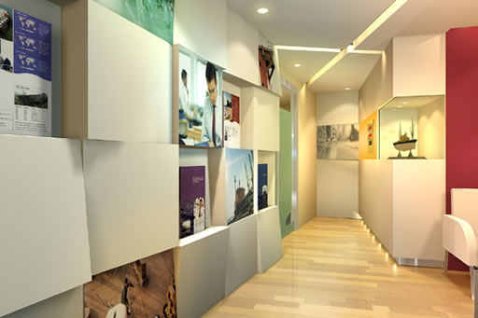
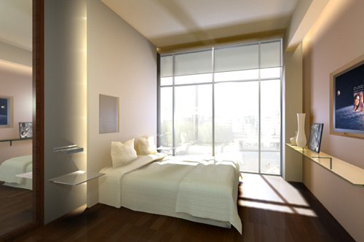
3D images by Narin Assawapornchai, gio_rin@hotmail.com(top) and Peangporn Boonmema,peangporn@yahoo.com (bottom)
So what color should we use for the ambient light in the scene? The color of the ambient light should be the average color of light affecting the scene + the average color of the entire room.
For example, skylight will influence a room with a large window or opening the most as the skylight (a kind of area light) will scatter around a large portion of the room or even throughout the entire room. So if the wall is a white or cream color, the ambient color should be blue(skylight) + white or cream which results in a yellow-green color. Also, don't forget to dim down the intensity of the color.
The sunlight itself will only affect the room in some parts, that is only the floor and walls as the sun is a directional light and it will not scatter around like the skylight, with exception to its indirect illumination from floor or wall. However, this indirect illumination will not have as much of an effect as the skylight.
If you still don't know what color you should use. I suggest that you go with a brown-grey first. I don't use pure grey as its lack of color will make the image look dead.
I have some suggestions about color below, but keep in mind these colors are not set in stone. You may use this as a guideline.

Example 1: The color of a room with a small opening
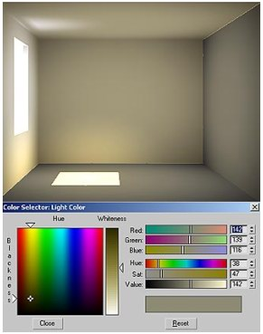
Ambient only R= 142 G=139 B=116

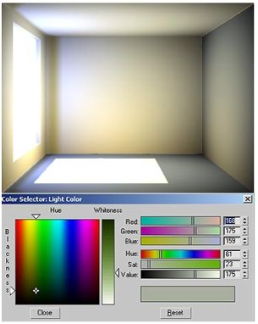
Example 2: The color of a room with a bigger opening

Ambient only R= 168 G=175 B=159
If we have any downlights or diffusers in the room, the skylight and sunlight are still considered stronger. If I give skylight multiplier = 1, the multipier of downlighs or any diffusers should be less. I always start creating lights whose multiplier is the strongest first.

->The 2nd picture shows that the multiplier of skylight is equal or lesser than downlights.
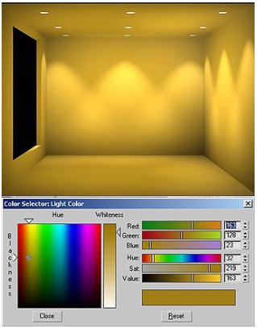
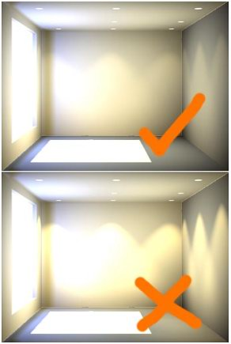
<- Example 3: The color of atmosphere of a room without natural light. Suppose the color or these down light is yellow.

Ambient only R = 163 G =128 B = 23

Example 4: The color of atmosphere of a room without natural light as well, but the light sources are more diffuse.
Ambient only R = 138 G =143 B = 117

Another interesting way to understand how to use color to make our renderings look better and more colorful is to understand color theory. I have read a number of books about painting written by artists. They always try to avoid black and grey becuase this causes images to look dead and colorless. Complimentary color is also interesting. An artist (I am sorry that I don't remember his name) says "Cool light(color) warm shadow(color) and warm light cool shadow." I am not too sure if this conflicts with our present science theory but as long as your work turns out very well and you call it "Art" , nothing is right or wrong. For example, if we see orange and blue (complemantary colors), you may think about evening time, as the color of sunlight appear orange in the evening and the ambient light is blue. Another example that is yellow and purple, yellow light goes well with purple ambient light.

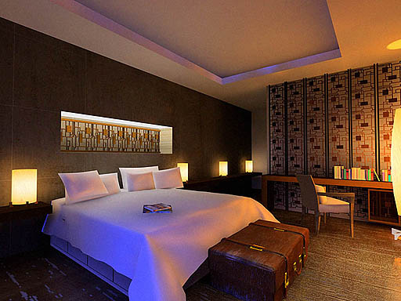
Example 5: The scene is filled with blue and orange light
http://www.cgarchitect.com/resources/tutorials/smoke3d/tutorial2.asp
Lighting and Shadow Basics - Part 2
by Montree T. (easyyong@hotmail.com) - Smoke3dStudio
Area Lights and Area Shadows
Another thing that a new user should not ignore is the beauty of area light. Area lights cause specular scattering on objects and blend with its diffuse area, creating a very soft look with beautiful soft shadows.
The bigger the light sources is, the softer its shadow will be.
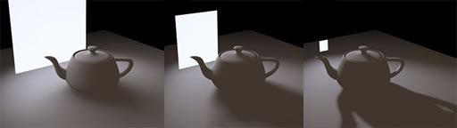

Indirect light is bounced light that reflects from an object when it is affected by direct light. The color of that light is affected by the color of the object. I also consider indirect light as a kind of arealight as well as the light is scattered from the object surface.
The area light is not that difficult to fake, but its soft shadow is what we need to pay more attention to. In Autodesk Viz 4, we have a new shadow type called the "area shadow" but the problem is that it takes a really long time to render. Some use many lights to fake this effect, (ie. skydome light) but that is for a still light or exterior rendering. For interior scenes, we can not use this method as there are too many objects in the scene to consider.
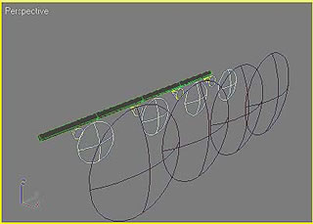
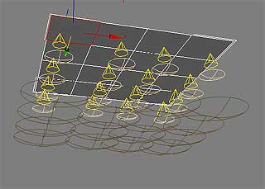
Figure 1: Area light, divided into small units and the units are replaced with free spots

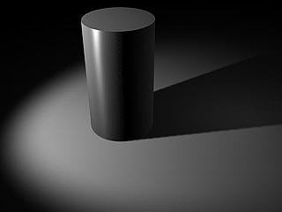
Figure 2: A shadow, casted by 1 single point light

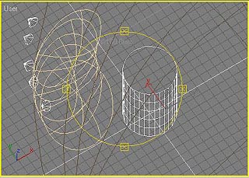
Figure3: Faking arealight effect, using spotlights

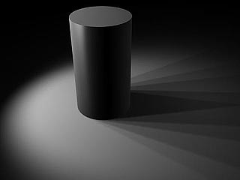
Figure 4: The shadow before changing size and sample range

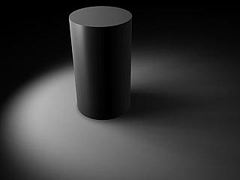
Figure 5: After adjusting size and sample range, The shadows looks smoother
There is another technique I have found using a negative parameter for shadow density to fake an area shadow. Sometimes if we use a lot of bright ambient-only lights in a scene, the default shadows may look faded or pale. The negative shadow value also helps to make the shadows darker.
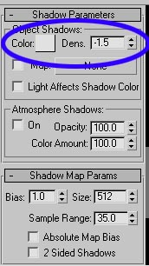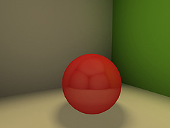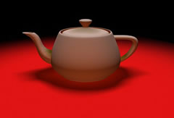
Figure 6: Shows the black color shadow with the default density parameter of 1 or more. You will see in the middle of the shadow area is brighter than the edge of the shadow.
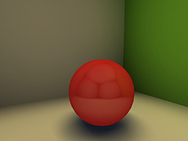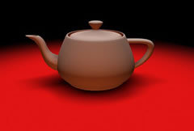
Figure 7: Shows the shadow with a negative density (-1,-2,-3). Due to the negative value, you also need to change the color of shadow to be whiter or light grey to inverse. The middle of the shadow appears darker than the edge. The result is a much softer look.
http://www.cgarchitect.com/resources/tutorials/smoke3d/tutorial3.asp
Lighting and Shadow Basics - Part 3
by Montree T. (easyyong@hotmail.com) - Smoke3dStudio
Step by Step
Let's start with a question: How many kinds of light affect the scene that we are going to create and which one is the affecting scene the most? In the last teo parts we leanred there are skylight from openings, Sunlight and indirect light. The skylight may have the most effect on the entire atmosphere color if the openings are big or it may be the color of the objects in the room.
1. Creating ambient
Once I know the color of atmosphere, I create an omni light as the main ambient light in the scene and enable "ambient only". Place the omni in the middle of the room then adjust the attenuation range. The "start" of the far attenuation should be fit to the room and the "end" of the attenuation is out of the room as shown in picture. I use uniform scale to scale down the Omni to fit to the height of the room so that the ratio between start and end should be around 1:2 or 3:5.
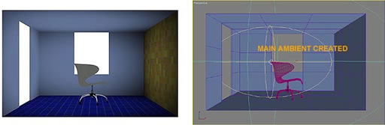
2. Creating soft shadows from area lights and indirect light
I usually make 2 layers of shadow for my interior scenes. The first layer is for the shape of the shadow from light source and the second layer is for soft shadows from indirect light and area light. The different look between soft and sharp shadows makes the scene look more fuzzy and realistic.
Basically, I always have one free direct under the ceiling and make the multiplier as small as possible. A typical value might be 0.1-0.2 and the color as dark as possible. What I want is only the soft shadow of every object in the room on the floor. Make the shadow color light grey and change the shadow density to a negative number like -1, -2 or -3 with a sample range as large as possible ie. 28-50. The negative shadow seems to be the easiet way for me to fake the area shadow. The advantage of the negative shadow is that it saves time during rendering. The negative shadow will appear darker or brighter depending on the color of the ambient light, so if the shadow appears very dark, you can reduce either the color or shadow parameters.
Casting these types of shadows is not limited to the floor. Sometimes I also place this kind of direct light to cast the shadow onto the ceiling or even on the wall.
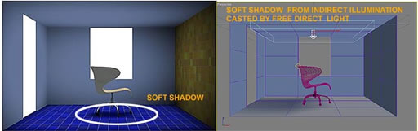
3. Add specular and diffuse pass from direct light
3.1. Creating skylight
When the skylight come into the room from opening ie. windows or doors, I consider those openings that the sky light came through as area light sources. Put new omnis as blue skylight outside every opening and adjust the far attenuation ranges to fit in the opening area. You may use cast shadow from these lights and the shadow should be soft as well.
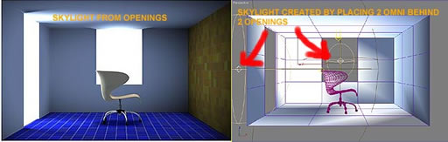

3.2. Sunlight
The sunlight itseft is not an arealight as the sun is only a small light spot in the sky, compared with the sky. (The sky is considered as a big dome of an area light) The sunlight shadow has a sharp edge. Sunlight is also considered as a directional light source.
Place a target directional light as a sun outside of the room, and set the shadow to a shadow map or raytrace and change the edge of the shadow to be sharp.

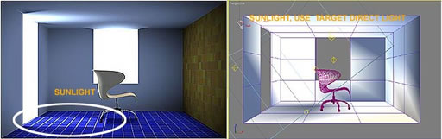
3.3 In case of we have any interior lights sources ie. Downlight or any diffuser, we also add them in at this stage. Don't forget that the bigger the light source, the softer the shadow will be.
Note: Sometimes, I finish the rendering without the sunlight and this may make the atmosphere look cooler. With the sun, the interior might look hot and look like it was in the middle of the afternoon.
4. Indirect light and illumination
Take a look around the whole scene again. I notice that there are 2-3 main indirect illuminations that we need to add.
4.1 Illumination from the big orange wall. I place an orange omni light behind the orange wall and make the attenuation as big as the wall size. Use ambient only. The ambient only light will also make the orange wall illuminte but if we put normal specular and diffuse light, it will illuminate only the rest of the wall, floor and ceiling. The advantage of ambient only is it will affect the opposite side of an object.
4.2 Illumination on the floor, affected by sunlight. When the sunlight touchs the floor, it will bounce and scatter to its surroundings. I put a color of blue (floor's color) + a bit of yellow tint omni (ambient only) under the floor and set the attenuation size to fit into the sunlit area. If you see the scene is too full of ambient only light, it will make the scene lack dimension. You may change the omni to diffuse and specular instead. This method is flexible, it depends on your sharp eyes.
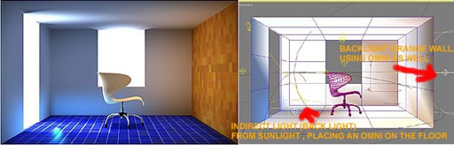
In a bigger interior scene that is more complex and has more indirect illumination, we might not put indirect light on all the illumination. Just placing a few main indirect illumination lights is enough as we are not the machine that can calculate all the illumination correctly. The look of the scene is based primarily on your sharp eyes. I also compare light to a brush that we are playing with on our artwork.
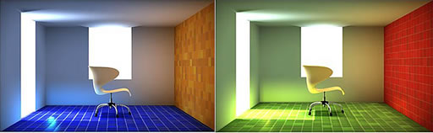
http://www.gamedev.net/reference/articles/article918.asp
Real-Time Radiosity
by Nathan Vegdahl
What is radiosity?
Radiosity is an addition to typical 3d rendering methods that increases the realism of any given image by a multitude. The theory behind it is that light does not just bounce off of objects and go into a persons eye, it also bounces off of objects onto other objects and then into the persons eye. And it also bounces off of objects onto objects onto yet more objects and then into the persons eye. And you can trace that until certain rays of light have bounced off of every single object in the room before it even reaches the eye. And that is actually what happens in real life! It results in something that one might reffere to as "color bleeding".
For an example of this, you could take a tennis ball, and hold it about a half inch away from a piece of white paper. If you look closely, the part of the paper that the ball is closest to has become a slight tint of yellow. That is the phenomena of radiosity at work.
Probably the most interesting thing about radiosity is that the human eye is very sensitive to it. If radiosity is not present in an image (such as with a typical 3d rendered image) your brain will flash a "not real" warning flag. That is why you can often tell that computer images are... well, computer images. You can tell that they are not real.
But many 3d rendering programs now have an option for rendering with radiosity. Lightflow (http://www.lightflowtech.com) for instance, has radiosity as a standard feature. In fact, it was designed around radiosity in the first place. Also, all composite computer graphics that you see in movies are typicaly rendered with radiosity Maya, for instance--which is a 3d graphics program used in many movies--can render with radiosity.
So how do you calculate radiosity? Well, it is a theoretically simple method, but that when put into practice is extremely complex and often unreasanabley slow. Of course, there is more then one method, but I am speaking of the traditional method. What you do is you first calculate lighting a single time, in the normal way, except you store the light values of any given polygon (i.e. how much light is reflecting off of it) as opposed to merely the color of the polygon after the lighting has been completed. Then, you use a recursive subdivision techneich to subdivide the meshes whereever there is an inconsistancey across it. You then re-calculate the lighting for the scene, storing the lighting values again. Except this time around you also take into account the light that is being reflected off of each of the polygons, and treat each of those as if they were a light source them selves. Also, you now have more polygons to calculate light values for because you subdivided them. You continue to do this until an user set thresh-hold, and then you stop. You now have thousands and thousands of polygons which all have their own light values, with radiosity taken into account. You then render the scene using interpolation ocross the surfaces of all polygons.
As you can see, that is an extremely time consuming, and memory hogging method. It should now be obvious that real-time radiosity is impossible, right?
Well, as I already said, that is only one of many methods. Lightflow, for example, uses an ad-hoc algorithm for all light calculation (including radiosity) that is much much faster then the traditional radiosity method. There are also ways to optimize the traditional method to make it a bit faster. There are also many other methods of calculating radiosity.
But all of those methods, however fast they may be for non-real-time calculations, are still not fast enough for real-time use.
So real-time radiosity is impossible. Right?
Wrong. The reason that all of the non-real-time methods are too slow is that they are all designed to acurately calculate radiosity. They are intended to be fully acurate! But we don't need full acuracey, we merely need enough acuracey for the human brain to not flash the "not-real" flag. And let me tell you, you really don't need all that much acuracey to prevent that.
With that in mind, I developed a real-time radiosity algorithm a year or so ago. I only mentioned it to a very few people, and a couple of businesses: Nvidia so that they could impliment hardware support... they ignored me; and Atari games, who did not ignore me, but were tentative in using the method... I'm not sure if they've decided to use it or not.
Anyway, I know for a fact that my method does not calculate acurate radiosity. However, I do know that it calculates enough acuracey to fool the human eye and brain into thinking that something is real.
So how does the method work?
Before I explain how my method works, I will first take you through my development of the algorithm, after which I will outline the method in full.
Meeting Ton
I while back, in 1998, I was broke. Well, actually, I'm still broke... but that's not the point. The point is that I couldn't afford to buy any 3d animation software (such as 3d Studio, or Lightwave, or even TrueSpace). So, I decided to search the net for a 3d animation program that was free. I already knew about Povray, and it didn't have very good animation capabilites; I ignored it. I then came upon Rhino, when it was still in it's beta, and free. But, of course, Rhino was a modeler, not a 3d animation program. Also, it was a NURBS only program, and I only knew how to model with meshes (from making Quake models and such).
Finally, I came upon a program called Blender (http://www.blender.nl), and it was a full fledged integrated animation/rendering/modeling program. And it was free! So, I downloaded it, and started using it. It turned out, however that the GUI was designed for efficiency, and not for ease of learning. So, I e-mailed one of the programmers of Blender, Ton. He was very helpful, and told me the basics of using Blender. Now, this was two years ago, and only 50 or so people used Blender, and probably only about ten more people knew about it, as opposed to now where it has become very well known, and there must be ten thousand users or so, and probably half of the internet knows about it. In fact, when I first started using Blender, no one had even thought about the C-Key idea, and the manual was still in the middle of being written.
Anyway, because of how few people knew about it, I was able to e-mail Ton many times after that. Most of the time I e-mailed him with feature ideas for Blender, because there were many features that seem standard in other programs that weren't in it (such as environment mapping, and translucent objects, and a UV editor). Then, at about the same time that the C-key system was implemented, I started coming up with ideas of my own, and not ones that I had seen in other programs.
The Reason for Radiosity
One of the C-key features in Blender was radiosity. However, there was a problem with it. The main problem I found was that it was not dynamic. What you did was you loaded the meshes (that you wanted to have radiosity calculated for) into the radiosity feature (which was practically a separate program). Then, you told it to calculate the radiosity for them. Once it had finished, you then spit the subdivided meshes back out into the actual scene. So, you couldn't calculate the radiosity once for each frame, you could only calculate it for one, and that had to be used for all frames.
The second problem was that it was slow. It used the traditional style of calculating radiosity, which is slow! Extremely slow! Other then that, I had no problem with the Blenders radiosity. In other words, everything except for the end image was bad. At that point in time I wished two things:
- I wished I had the C-key.
- I wished there were a faster and more easily dynamic method for calculating radiosity.
The strange thing about what happened next was that I never sought out to develop a faster radiosity algorithm. In fact, the idea actually came to me at a time where I wasn't even thinking about radiosity at all, it came while I was watching TV.
The Click
So, I was watching X-Files, sinking into the recliner chair. All of the sudden, I realized that diffuse light was merely specular light that was equally reflected in all directions within 90 degrees of the surface normal (a total of 180 degrees), because of micro-facets in surfaces. Then, I thought of environment mapping. It was used to simulate specular reflection. So why not use it for diffuse reflection too? Why couldn't you use a cube-rendered view to calculate radiosity?
That was the beginning. However, I only had a vague idea of how to do it: render cube view, use it to calculate diffuse light interaction. So, I still had no idea how to use the cube view to calculate the radiosity, I just knew, by some intuition, that you could.
The Development
So, I turned off the TV (yes, in the middle of X-Files), and ran to get some paper. Now, perhaps you think that I used it to write things down on. However, I did nothing of the sort. What I used the paper for was I used it to clearly see real-life radiosity. I put the piece of paper on the table, and I quickly ran to by room to get varios objects of different colors.
I first took a red colored marker and put it just above the paper. The red color from the marker casing was slightly visible on the piece of paper. I then moved my head around the paper and marker, making sure to keep them both still. What I saw was that the radiosity did not change as I moved. In other words, diffuse light did not change as the view point changed. The reason I did that was because specular reflections do change as the view point changes: the reflection "deforms" (so to speak) as the viewer moves. Then I moved the marker, and the faint red on the paper moved. So, I now knew that radiosity did not change with viewpoint change, but it did change with object change. I had already known both of those things, but for some reason I just wanted to make sure.
Next, I picked up one side of the paper, so that it was tilted. I noticed that although the paper moved, the red spot did not. That is not so say that it didn't move relative to the paper (which it did), but what I mean is that if you looked at the entire setup from above, looking down, the marker would always be obscuring the same part the red-spot. However, there was a change in the red spot, it merely wasn't it's position. The change was it's intensity. The further and further the paper tilted, the fainter and fainter the red spot got, until eventually, it disappeared. And the place that it disappeared at was when the paper was completely vertical. That meant that it had the same attributes as regular diffuse light from light sources! The higher the difference in angle becomes, the lower the amount of light contributed becomes!
After that, I set the paper down, and then started sliding it, while keeping the marker still. What happened was that the red spot stayed the same relative to the marker, which confirmed what I had discovered by tilting the paper.
I made the following definitions:
- the marker is a source.
- the paper is a receiver.
And with those definitions, I came up with the following rules:
- view point change has no effect.
- position of radiosity "color bleed" always stays relative to the source.
- intensity of radiosity "color bleed" lowers as angle between receiver-surface-normal and source-to-surface-vector (the vector made by drawing a line from the source to the surface) increases. Also, a rather obvious (given) rule was that the radiosity decreased as the light cast onto the source decreases (i.e. an actual light source changes position or intensity).
And to think, I would have gotten no where if I had used the marker and paper to write out algorithms!
The Application of Rules
The difficult part, however, was not discovering the rules, but figuring out how to use them to my advantage. The situation was much like attempting to create a rocket ship: you know the laws of physics, but how can you use them to get the rocket into the air?
The first thing I figured out was something called normal texture mapping. Now, perhaps that sound rather funny, seeing as normal is a rather subjective term. But that is not what is meant my "normal". What it is referring to is the surface normal of any given point on a surface.
Traditional texture mapping was done by defining an "imaginary" box, with each of the sides of the box having part of the texture map on it. Then, lines were projected and reflected all over the place, and once they intersected a place on the box, that color was recorded and assigned to the origin pixel. In fact, it was quite similar to ray tracing in some respects. However, there was a difference. Instead of actually projecting a ray from the view pixel, you instead projected a line from each vertex of the mesh in question. The direction of the line could be formed in several different ways, all of which caused the texture map to be mapped onto the object in a different way.
A rather standard way of forming the lines direction was by projecting a line from the origin of the object through the vertex in question, which was referred to as spherical mapping. Another method was to project the line from a z/x origin point, but with the y value of that point always being equal to the vertex in question, which was referred to as cylindrical mapping. There were many other methods used, one of which was normal mapping.
Normal mapping formed the direction of the line by merely using the surface normal of the vertex in question. This was very fast, because you didn't have to generate the line direction during the rendering, you merely made it equal to the surface normal.
Then, you used the direction of the line, and projected it from the position of the vertex. The line would intersect with the imaginary cube, and what ever UV coordinate it hit, you would assign to that vertex. You would do this all of the vertices, and all of the sudden you would have all of the UV coordinates you needed to do the texture mapping!
What I decided was that normal mapping would be used to define UV coordinates used from the cube view. But why? The reason why was because of rules #2 and #3. This would make a change in the vertices angle (i.e. surface normal) to cause a change in the color which of the vertex in question, because the UV coordinate that it was assigned to would change, and a change in the vertices position would also cause a change in the UV coordinates. Also, the view point has no effect on normal mapping.
But I still had a problem. A change in angle was not supposed to change the color completely, it was only supposed to cause it to fade in and out. How was I going to fix that? And then it hit me: blur. If you blurred the cube view, it would cause colors to fade in and out, instead of just appearing and disappearing. But how much blurring was I supposed to do? That, also, came to me almost instantly. Since diffuse light was defined as specular light being distributed evenly over 180 degrees. Therefore, I would have to blur the cube view so that any given pixel would contribute evenly to all pixels that were 180 degrees around it. In other words, all pixels contribute evenly to all pixels within the half of the cube view closest to it.
The last problem I had was that using a cube view as a texture map would merely make it look like a deranged reflection, because you would see the image. Then I realized that the blurring I already thought of solved this problem because it would eliminate the sharp defined image, so it wouldn't look like a reflection at all because you wouldn't be able to see what anything in the blurred image was.
The last necessity
The last thing that needed to be added to the method was light. In other words, you couldn't just map the texture onto the object, you had to use the color values as light values. The reason for that is that if you did not, you would never see the color of the texture in completely dark areas, which would completely eliminate the point of the algorithm.
So, you would light the world like normal, and then you render the cube view for all objects, and use the method I described to blur and map the UV coordinates onto the object. After that, you added all of the color values of the cube-view texture maps to the light values of the object. You would then render the scene.
Ton again
I franticly logged onto the net and e-mailed Ton, outlining my method in detail. His reply to my message was that that method had already been developed, and it was called "hemicubes". I was extremely disappointed. I had thought that I had come up with something new, and it turned out that it already existed. So, I decided to do some quick research on hemicubes.
What I found out was that hemicubes was not the same thing as my method. In fact, there was only a single similarity: the cube view rendering. Other then that, it was pretty much completely different. It was used in a completely different way! Instead of mapping it onto the object, it rendered a separate half-cube view for every polygon of the model. In fact, it was merely a modification of the traditional method of radiosity! It was used as a replacement of measuring the distance between polygons. IT wasn't at all the same!
So, I e-mailed Ton back, carefully outlining the differences. He agreed with me that my method was different. However, he still wouldn't put it in Blender... at least, not yet. The main reason behind that was that he had other things that he felt were more important to implement. And I could definitely understand that.
But I was still disappointed. I was hopping to see my method in action. And I didn't want to implement it my self because I had no base 3d renderer to program it for, and I didn't want to take the time to program one merely to test out a single idea of mine.
The realization
At that point I still hadn't realized the true implications of my radiosity method (which I had named "radiosity mapping"). But it happened quickly enough.
I was playing Quake (the original) when it occurred to me. I had suddenly gib'd a knight, and I saw the flash of the rocket exploding. GAMES!!! I suddenly thought to my self. They could do environment mapping with games, and they certainly could do texture mapping.
Gameprog.com
At that point in time I was a frequent visitor to gameprog.com. I had already writen a couple of tutorials on 13h programming and pallete manipulation, but I had never writen anything original. So, I decided to start writing up an article, outlining my method.
The only problem was that I got side tracked, and I never finished the article. And I had never told the webmaster about it. So the article just sat and rotted.
The present
At the present, a year and a half later, I have been inspired again. I have now written this article, outlining my method and it's development. I very much hope that someone will read this article and decide to use my method in their game. I will say right now that I do not care if I get credit or not. I do not care if I get money or not. I just want to see my method in action. If anyone does use radiosity mapping in their game, PLEASE e-mail me and let me know!
Basic outline of radiosity mapping
This last section is a quick list of all of the steps in radiosity mapping.
- render cube view from object origin.
- blur cube view so that all pixels contribute their color equally to the half of the cube view closest to them.
- use normal mapping to acquire UV coordinates for each vertex of the mesh.
- texture map the cube view onto the object, except DO NOT USE PIXEL COLORS AS YOU WOULD NORMALLY, instead, use the pixel colors as lighting values, and add those light values to the light already present on the object from traditional lighting methods.
- Render the scene with it's new light values.
Optimizations
There are some rather obvious optimizations that could be implemented along with this radiosity method. I am going to lightly outline the ones that I have thought of in this section.
The first one is to not do full texture mapping for the cube view. Instead, only find the light values for each vertex in the mesh, and then interpolate.
The second one is that you could ignore the radiosity calculation of static objects, and only do radiosity mapping for dynamic objects. You could pre-calculate the radiosity for static objects by using traditional methods. Then, for the dynamic objects light contribution to the static objects, you could pre-calculate a volume of light-contribution values that moved with the object. Then, as the light of one part of the dynamic object changes, so does the corresponding section of volume. The volume would move with the object. Then, you light the static objects according to the light volumes of the dynamic objects.
"Thank you"s
There are several people who helped me develop this method (some without there knowledge), and I would like to take the time to give a list of those people here:
Ton Roosendaal (Not a Number)
John Carmack (Id Software)
My mom (yes, she really did help me develop this)
Chris Lattner
Will Kerslake (Atari Games)
Allan Watt
My thanks go out to all of you!
Last thing
One last thing. If you were confused by anything in this article, or if you have any questions, or even if you'd just like to compliment me on my original thinking (smile) then PLEASE feel free to e-mail me! My e-mail address is nathan_vegdahl@yahoo.com
Discuss this article in the forums
Date this article was posted to GameDev.net: 2/19/2000
(Note that this date does not necessarily correspond to the date the article was written)

http://www.gamedev.net/reference/programming/features/shadows/
Shadows
by Michael Skinner
Introduction
So, you want to add shadows into your games. Why? Maybe it’s because it looks cool, maybe you want to brag about it to your friends, or maybe you think it will add to the game atmosphere. Whatever your reason, you’ve definitely come to the right place!
Ok, ready to get started? Well, we’re going to start with the very basics here. What is a shadow? Webster defines a shadow as "an area that is not or is only partially irradiated or illuminated due to blockage of light by an opaque object," or "the rough image cast by an object blocking rays of light." For our purposes, a shadow is a dark area caused by light being blocked by an object. So why exactly do we need to know this? Simple, if we know what a shadow is, it will be that much easier to create them in our games.
The most obvious solution is presented by the definition of a shadow. We could just cast a bazillion rays from the light source and determine lighting that way. While this may work, it’s computationally expensive (i.e. slow), and it isn’t very easy to implement. So, are you getting sick of definitions yet? Well, you’re in luck; you now know all you need to know to get started.
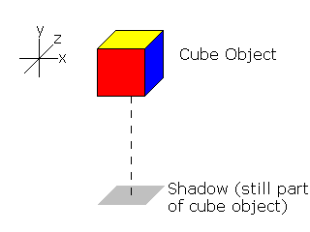
Ok, so I lied, there is one more thing you have to know before we get started, these algorithms are ordered based on complexity, the easiest algorithms are first, and the more complex ones are at the end. Ok, here we go!
Fake Shadows
The simplest way to create a shadow is to add a polygon to the bottom of the object. Since this is best understood visually, you should take a look at figure 2.1 if you don’t understand the concept.
Figure 2.1
This is a very simple way of doing things. Unfortunately, it’s very limited in it’s applications. The ground must be flat, the object has to remain a fixed length above the ground, the object can only rotate around the y-axis, it doesn’t take into account the direction the light is coming from, and it doesn’t shadow anything other than the floor. But, we’re only getting started, and the next three algorithms are much better, if a little bit slower and more complex.

Vertex Projection
This method is still very simple, but it is considerably better than the last one. In this method, you project each polygon onto the ground. If there is any confusion, look at figure 3.1.
Figure 3.1
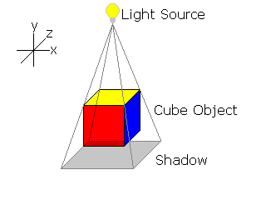
The calculations for this method are incredibly simple, as you can see in listing 3.1
Listing 3.1
void shadow_poly(Point3D p[], Point3D s[], Point3D l, num_verts)
{
for (i=0; i<num_verts; i++)
{
s[i].x = p[i].x – (p[i].y / l.y) – l.x;
s[i].z = p[i].z – (p[i].y / l.y) – l.z;
}
}
(Where s is the shadow vertex, p is the object vertex, and l is the point the light originates from.)
Although this is much better, this algorithm is still pretty simple, and restricted in it’s use. Once again, it only works if the ground is flat and it still doesn’t shadow other objects. Don’t worry though; there are still two more algorithms!
Shadow Z-Buffers
Ok, so we’re ready to get down to the more complex algorithms. This method is not the most complex, but it is probably the most efficient of those discussed here.
Basically, what you do is create two Z-Buffers, one from the viewpoint of the camera, and one from the viewpoint of the light. When it’s time to render, you have to go through several steps for each point. For all of the visible points, you need to map from camera space into light space. Project these light coordinates into 2D, and use x’ and y’ to index into the light-viewpoint Z-Buffer. If the light-space Z coordinate is greater than the Z-Buffer value, then the point is shadowed. See figures 4.1 and 4.2 to clear up any confusion.
Figure 4.1 Simple scene as viewed from the camera’s point of view
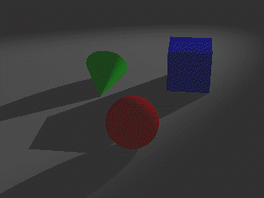
Figure 4.2 The same scene as viewed from the light’s point of view (notice that there are no shadows visible)
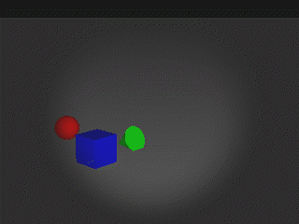
The light viewpoint Z-Buffer would be created before you even began to render the scene from the camera viewpoint. This step would be done just as if you wererendering from the camera viewpoint, the only difference being the position from which you were viewing the scene. After this Z-Buffer creation you have to go through about three separate steps for each point in the camera Z-Buffer.
The first step you go through for each point is probably the hardest, and it’s not very hard. You just need to translate and rotate the point until it is in the correct position. This sounds complex, but it is actually very simple. You just translate and rotate everything by the difference between the camera and the light. The psuedo-code in listing 4.1 is easier to understand, so just take a look at it to clear up any confusion.
Listing 4.1
point.x += (light.x – camera.x);
point.y += (light.y – camera.y);
point.z += (light.z – camera.z);
point.rot_x += (light.rot_x – camera.rot_x);
point.rot_y += (light.rot_y – camera.rot_y);
point.rot_z += (light.rot_z – camera.rot_z);

project points into 2d

point.screen_x *= LIGHT_X / SCREEN_X;
point.screen_y *= LIGHT_Y / SCREEN_Y;

if point.new_z > light_z_buffer[point.screen_x][point.screen_y] ;
{
return(shadowed);
}

return(not_shadowed);
The second step is simple, you just project from 3D down into 2D, just like you normally would. The next thing you do is simply change from the aspect ratio of the screen to the aspect ratio of the light Z-Buffer (probably 256x256, or some other square view port with dimensions that are powers of two).
The last thing you need to do is simply compare the mapped Z value to the value in the light Z-Buffer for the projected coordinates. That’s it; you have just produced accurate shadows that, if they are a bit blocky, look great and take very little effort.
Although it is the most efficient algorithm, it still has several downsides. The first is that shadows can appear blocky depending on the resolution of the light Z-Buffer. An obvious downside is that the scene takes longer to render due to the fact that you draw it twice. The worst downside, however, is that the light has to be directional. This means that you can’t have point light sources, unless you want to render the scene six times from the light viewpoint (one for each direction: up, down, left, right, forward, and backwards). As you can imagine, that would make your engine very slow. Ok, so even this engine has some limitations. However, I’m sure it could be optimized so that you could have point light sources.

Shadow Volumes
This method is definitely the most complex of all the algorithms discussed here. It produces very nice results however, but it is incredibly slow for high detail scenes.
This method requires a little bit of explanation. First of all, what the heck is a shadow volume? A shadow volume is an infinite volume of space where light cannot be seen because it is being blocked by a polygon.
Making this volume is probably a lot simpler than you might think. All you have to do is make a vector from the light source to each of the vertices of a polygon (the code for this can be found in listing 5.1). After you have these vectors, all you need to do is normalize them and voila, they combine to form an infinite volume. Clip this infinite volume to the viewing volume, and you have your usable shadow volume. All you need to do now is check to see which polygons are within these volumes, and darken accordingly. As usual, look at figure 5.1 to clear up any confusion. Although checking entire polygons against the volume may be the simplest solution, it may not work for all situations (e.g. large polygons would not be shadowed correctly, leading to bad shadows and a messy looking game engine). However, there is hope. You can clip all of the polygons that pass the first test against the shadow volume. This test requires only a little processor power per polygon, but if you have scenes with high polygon counts, it could seriously slow your game engine. This usually isn’t an issue however, because if you have high polygon counts, then your polygons are probably going to be fairly small. The only exception to this is in scenes where you have tons of low detail models.
Ok, so you don’t like clipping, there is another alternative that does not involve any clipping or checking against volumes. This alternative even has a name; it’s called a stencil buffer. To use a stencil buffer, you check to see how many shadow polygons a ray from the viewpoint to the point you are checking. If the number of shadow polygons is odd, then the point is in shadow. A problem arises, however, when the viewpoint is in a shadow. Shadowed objects would be lit as if they were not in shadow, and non-shadowed polygons would be shadowed. While this may produce a neat looking effect, it is not what we want to be doing. All we need to do to alleviate this problem is to cap the shadow volume. To do this, we just check to see if the shadow volume passes through the near clipping plane. If it does, then we just need to create a polygon that covers the portion of the near clipping plane that is in the shadow.
Figure 5.1 Example of a shadow volume (anything inside of it is shadowed)
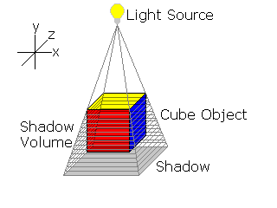

Listing 5.1
void create_shadow_volume(Point3D p[], Point3D l, ptr_Vector3D ray[], _ numPoints)
{
for (i=0; i<num_points; i++)
{
ray[i].x = p[i].x - l.x;
ray[i].y = p[i].y - l.y;
ray[i].z = p[i].z - l.z;

normalize_vector_3D(ray[i]);
clip_to_view_3D(ray[i]);
}
}
Even this algorithm has its downsides. The first is that is that it slows down significantly with complex scenes. It is also incredibly difficult to add another light into the scene. If you have a scene with only one light, fairly simple objects, and you can’t stand having a flat floor; this algorithm is probably the best choice.
Combining Algorithms
Although this article presents only different algorithms, I thought it would be nice to let everyone know that many of these algorithms can be combined to form even better ways of doing things. I don’t mean just supporting several of them and using different algorithms for different situations. What I’m talking about is combining two or more algorithms into a single algorithm. For example, the Shadow Volume algorithm and the Shadow Z-Buffer algorithm can be combined into a single algorithm. Although this has been done already, there are more combinations possible. Another possibility would be to use the vertex projection technique on uneven surfaces; it would just take a little effort and ingenuity. Seeing as how it would be difficult to imagine combining these algorithms without an example, so I will present you with the combination shown above, the new algorithm is called Shadow Volume Reconstruction.
The basic algorithm is that you create a Z-Buffer from the point of view of the light (just like in the Shadow Z-Buffer algorithm). After that you run the light Z-Buffer that you just produced through an edge filter. This edge filter is then used to produce a silhouette polygon. The silhouette polygon is then used to create a shadow volume. This may seem a little excessive, but the results do look smoother than the usual Shadow Z-Buffer algorithm, and it is easier and faster than the Shadow Volume method.
Ok, now that you know the basics of the method, it’s time to go into a little depth. There are seven general steps to the Shadow Volume Reconstruction method. The first step is to render the shadow z-buffer. The next step is to render the scene from the standard camera view. The third step is to reset all of the buffers (the stencil buffer, the depth buffer, etc.). After resetting the buffers, you need to create the silhouette image. This can be done with a simple edge detection algorithm (see listing 6.1). By using the silhouette image you just created, you can now reconstruct the shadow volume. All that is left to do after creating the shadow volume is cap it, and then darken the shadowed pixels.

Listing 6.1
void edge_detect (int u[], int v[])
{
int x, y;

for (x=0; x<SCREEN_WIDTH; x++)
{
for (y=0; y<SCREEN_HEIGHT; y++)
{
u[x, y] = (|Δ_{x} z[x, y]| > θ)
v[x, y] = (|Δ_{y} z[x, y]| > θ)
}
}
}
Where:
Δ_{x} z[x, y] = |z[x, y] – z[x + 1, y]|
Δ_{y} z[x, y] = |z[x, y] – z[x, y + 1]|
The first step is simple; you’ve done it before. You just render from the light’s point of view like you did in the Shadow Z-Buffer algorithm. The second step also follows the Shadow Z-Buffer algorithm. You just create the z-buffer as you normally would when rendering any scene. The next step is simply to make sure the data is correct. You reset the stencil buffer (this is used to determine whether an object is in shadow or not) and disable writing to the screen and z-buffers. The fourth step is when we start to deviate from the Shadow Z-Buffer method. What we need to do now is run the shadow map through an edge detection filter. This is fairly simple and doesn’t require an overly complex filter (an example of a suitable filter is presented in listing 6.1). Now is when things start to get a little complicated. What we need to do now is create a shadow volume based on the silhouette image. This can be done in two different ways. The first approach is to generate the parts of a mesh that touch at least one silhouette edge (this sounds confusing so take a look at figure 6.1). The second method is similar, only it uses a lookup table to determine what the mesh should look like. The lookup table would simple contain the 16 possible combinations of four adjacent pixels. This is also a confusing concept, so look at figure 6.2 to better understand what is going on.

Figure 6.1 Generating the mesh – Approach I
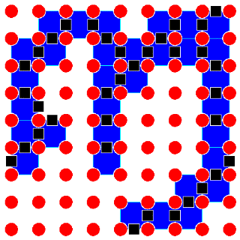
Figure 6.2 Generating the mesh – Approach II
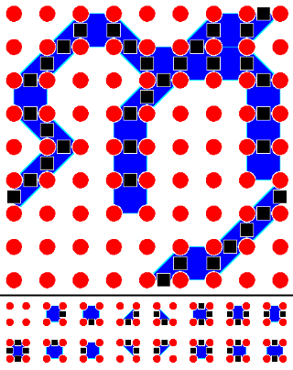

Ok, so now that you have seen the algorithm, you might wonder what makes it better than any of the other algorithms. Well, this algorithm is a compromise; it doesn’t have the speed of the Shadow Z-Buffer method. However, it looks smoother, but not as smooth as the Shadow Volume method. It is an in-between, and it was intended to show that Shadow Volumes and Shadow Z-Buffers are similar and have different strengths that can be combined in a hybrid.

Conclusion
So, now that you have seen several different algorithms, and even a hybrid, you are ready to create your own shadows. These algorithms are not the only choices, the possibilities are endless, new algorithms could be created, or older algorithms could be combined. The sky is the limit.
Experiment! Only if you dare to be different and create your own methods will you make progress. Even if your method is not as fast or accurate, it is more than likely that it can be used as a stepping stone, for yourself and others, to make real-time shadows more accurate. So, don’t just sit there! Explore, create, expand, EXPERIMENT!
If you are inspired by this article and create a brand new algorithm, or just have an existing one you would like to let me know about, please send me an e-mail to let me know about it. Also, if this article was helpful to you in any way or you have any questions, suggestions, or comments, feel free to e-mail me atmike91285@aol.com.
Discuss this article in the forums
Date this article was posted to GameDev.net: 2/6/2001
(Note that this date does not necessarily correspond to the date the article was written)
See Also:
Shadows

